系统方案
Cartrack - Home of Connected Vehicles
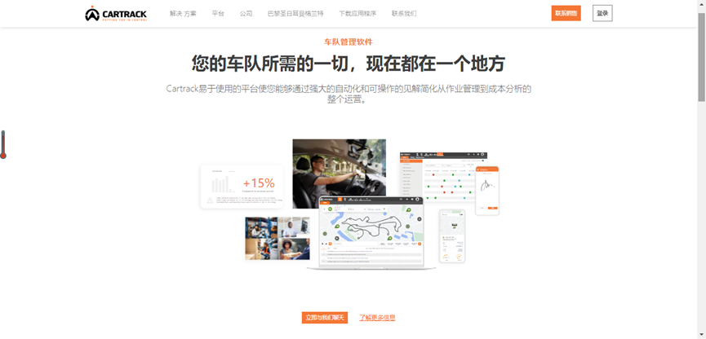
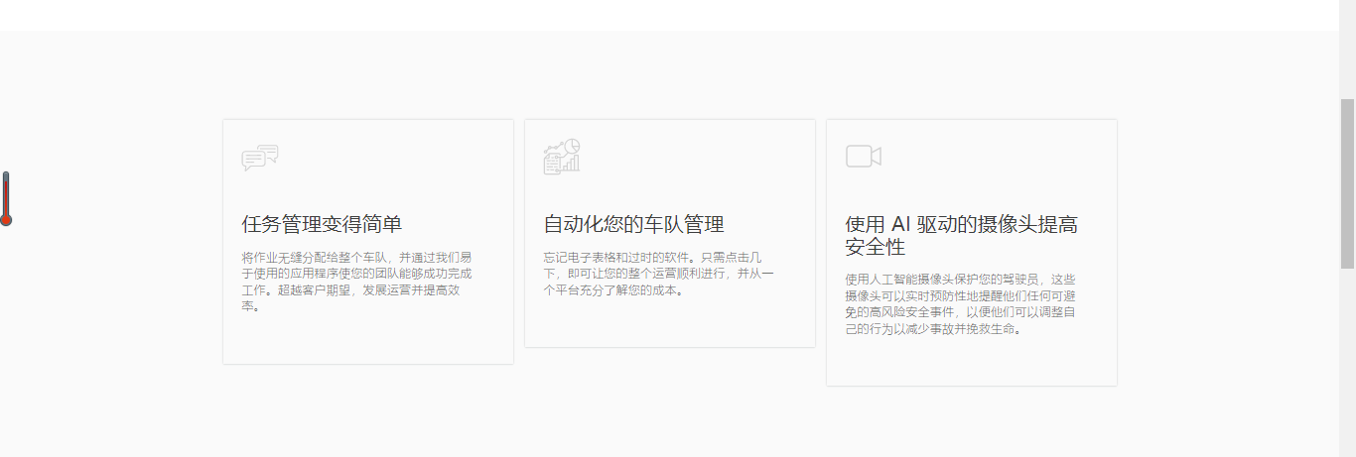
系统特点
系统介绍
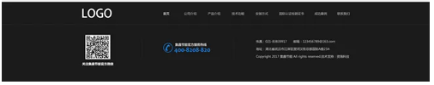

解释：
【需要文字和图，讨论】
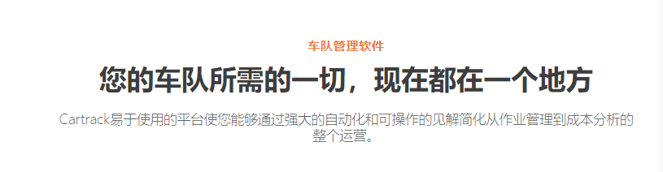
模仿稿 | 设计稿文字（定位）
车队管理软件 | Fleet Management System
您车队所需要的一切，现在都在一个地方 | 车队所发生的一切，您都了如指掌
Cartrack易于使用的平台使您能够通过强大的自动化和可操作的见解简化从作业管理到成本分析的整个运营。 | Create使用*****

模仿稿 | 设计稿文字（变形监控）
车队管理软件 | Deformation Monotoring System
您车队所需要的一切，现在都在一个地方 | 建筑、桥梁发生的一切变形，您都了如指掌
Cartrack易于使用的平台使您能够通过强大的自动化和可操作的见解简化从作业管理到成本分析的整个运营。 | Create使用*****

小图标的位置，放01，02，03，这种
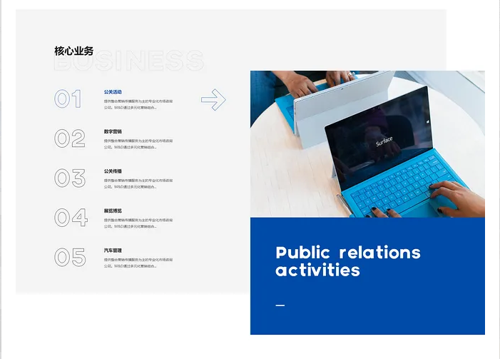
Fleet Management System
介绍：
Use our reliable vehicle tracking sensor based on multi-system GNSS+IMU technology, you will be able to track your vehicles accurately (traffic lane level precision) and reliably in dense urban areas, inside tunnels and underground/indoor car-parks. The solution also includes possibilities to integrate with DSM (Driver Status Monitoring) devices to better manage the fleet for efficiency and safety.

特点：
- Visual display of the vehicle's real-time position
- Automatically generate all kinds of system information and safety warning information
- Graphical analysis of work area utilization and performance of selected vehicles
- Trace the history of the selected vehicle
- Off-course alarm
- Automatic generation of vehicle aggregation analysis and stall timeout alarm

Vessel Monitoring System
介绍：With our cm-level GNSS positioning sensor, the Vessel Monitoring System is able to accurately and indisputably measure the time duration in which a vessel is at the berth thus triggering charging for the service of utilizing the berth. The solution integrates with feul level monitoring, cabin status monitoring to provide full tracking of vessels during its daily operations for fraud prevention, efficiency improvement and safety.

特点：
- Visual display of the vessel's real-time position
- Automatically generate all kinds of system information and safety warning information
- Enter danger area warning
- Graphical analysis of work area utilization and performance of selected vessels
- Trace the history of the selected vessel
- Off-course alarm
- Automatic generation of vessel aggregation analysis and stall timeout alarm

Deformation Monitoring System
介绍：Using our innovative mm-level monitoring sensor and back-end software algorithms, the solution provides long term continuous monitoring of structures such as bridges, high-rise buildings for deformation. The system can provide early warning in case of potential catastrophic incidents as well as providing unprecedented vast amount of structure change data which can serve as valuable input to the design improvement and optimization in structural design.

特点：
- The system can collect and process the deformation data continuously, automatically and in real time.
- Analysis, process line drawing, judgment, prediction, report printing and Web publishing.
- The warning value is set for the deformed body to realize the over-limit alarm function.
- Visualizes the real-time deformation monitoring.
- The system can collect and process the deformation data continuously, automatically and in real time.
- According to the processing data, the control center realizes analysis, process line drawing, judgment, prediction, report printing and Web publishing.
- According to the relevant standards and experience data, the warning value is set for the deformed body to realize the over-limit alarm function.

Construction Site Safety Solution
介绍：Integrating location tracking and A/V sensors and sound alarms into a standard safety helmet, transforming the most popular worksite PPE (personal protection equipment) into a smart safety solution so that work site safety can be digitally enhanced. It allows on-site safety supervisors as well as remote safety centers to have full work-site safety situational awareness, to automate safety alerts through geo-fencing thus reducing accidences and safety violations. The system also records personnel tracks and events, for post morten analysis in case of safety accident or violations.

特点：
- Obtain accurate location information of personnel in real time.
- Dynamic display of the movement of people under the tower crane, loading and unloading area, container stacking area.
- Integrated heat map analysis of employee distribution and statistics of employee activity mileage to optimize personnel scheduling.
- According to the safety requirements of the port, set up various types of electronic fences and working areas, and formulate personnel safety strategies.
- Monitor the implementation of safety policies and correct personnel violations.
- Provide a variety of alarm means to ensure personal safety of personnel, reduce safety expenditure.

Safety Supervision and Communication System for Large Groups
介绍：Lightweight personal tracking and communication device in the form factor of a badge, conveniently worn using lanyard. Equipped with a check-in button to report safety and location, two-way voice communication capability for reaching to SOS centre or pre-programmed numbers for assistance. Long battery life and reusable from group to group.

特点：
- HELP ASSIST
Request help from your colleagues at your location or ask for help from professional assistance organizations.

- TRACK
Automatically send and save your real-time location and allow contacts to track your progress using SIRUS® MSS portal
No movement detection
CHECK IN Let contacts know where you are and that you’re okay with a pre-programmed message.

- CUSTOM MESSAGE
Play the broadcast message.
S.O.S. In an emergency, to send an S.O.S. message to a pre-determined designation
Require a 4G SIM card for connectivity
SIRUS® MSS portal

School Student Care System
介绍：Lightweight personal tracking device tailored for application for school children safety in the form factor of a badge, conveniently worn using a lanyard. It allows the school to ascertain that the children is inside the school or outside, allows the parents to ascertain that the child is en-route or at home. When abnormal location or situation is detected, alerts can be generated to both school and parent.

特点：
- TRACK
Automatically send and save children's location and allow contacts to track their progress using SIRUS® MSS portal
Abnormal Location alarm
Fall or No movement detection

- CHECK IN
Let parents know where children is and that his/she is okay with a pre-programmed message.

- CUSTOM MESSAGE
Play the broadcast message.
S.O.S. In an emergency, send an S.O.S. with children’s location to a pre-determined designation
Require a 4G SIM card for connectivity
SIRUS® MSS portal

Equipment Tracking System
介绍：Equipment ranging from bulldozers, tractors to trolleys and fork-lifts need to be tracked so that they can be better managed against theft, mis-placement as well as improving utilization and sharing. This solution manages equipment in various operating environment using suitable IoT sensors and communication technologies.

特点：
- Track the transportation process of equipment from factory to construction site, which can be carried out across borders

- TRACK
Automatically send and save the location and allow management to track the progress using SIRUS® MSS portal
Off-course alarm
Motion monitoring
Require a 4G SIM card for connectivity

Firefighter Tracking System
介绍：
A custom-design and made portable system for on-site commander to track each and every fire-fighter sent into a multi-story fire site. It does not rely on any infrastructure in the target building nor having access to its floor map. The system allows a fast 3D model generation on the fly, giving the commander a visual situation-awareness on the locations of each fire-fighter sent into the building. The graphical situation can be remotely accessed from regional command centre. The body-worn device by each fire-fighter can detect immobilization, fall of the soldier, and also support audio and visual alerts and commands from the on-site commander. The operation can be played back from post event analysis and training and improvement purposes.

特点：
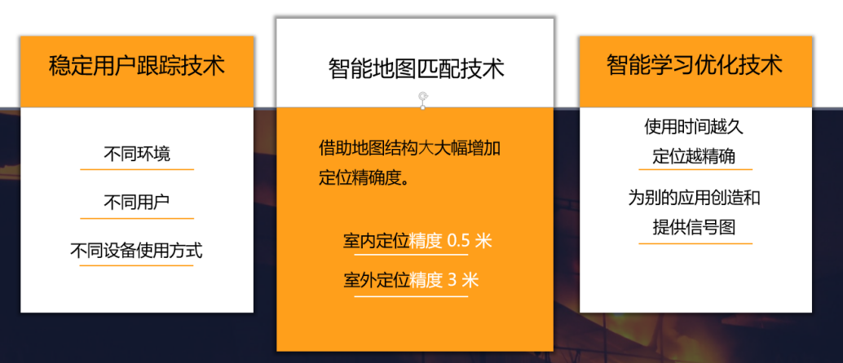
UWB Anti-Collision System
介绍：This proximity alert solution provides moving objects such as fork-lift, cranes and personnel to be aware of each other when they come too close to each other. It works as a stand-alone system without the complexity of communication networks, software portal etc. Just beacons (for the moving machinery) and tags (for the people around it). The distance of alert can be pre-set to the desirable safety level. When the equipped machineries and people come within the distance, audio and visual alerts are triggered to the operator and the personnel nearby to avoid accidents.

特点：
- Provide high precision ranging between vehicles and personnel.
- Provide real-time safety alerts for drivers and staff to prevent accidents
- Support 1D/2D/3D positioning methods, real-time monitoring range of 100m radius
- Insensitive to target moving speed, suitable for a variety of work scenarios
- Long battery life huge system capacity, supporting up to 6500 tags

UWB Real-time Tracking System

介绍：
The Ultra Wide Band (UWB) positioning solution provides high-accuracy, low-latency indoor position and location of moving objects. This is suitable for applications that derive contextual information through monitoring interactions between tracked objects and their environments.
This UWB localization solution gives better micro-positioning precision (close to 10 cm level of accuracy) and real-time localization with millisecond-level latency, high consistency and high repeatability.
UWB solution is suitable for tracking of high-value, hazardous goods or personnel working in hazardous environment, e.g. explosive, petrochemical containers, mining, etc. tracking of fast moving machinery and vehicles, e.g. smart factory, logistics, etc.

特点：
- Indoor and outdoor location data access
- Trajectory tracking and heat map analysis
- Customizable interface with customer's existing systems
- Centimeter precision positioning algorithm
- Low latency of Position data distribution
- Cloud based platforms to adapt to different application scenarios
- Highly cost effective

