home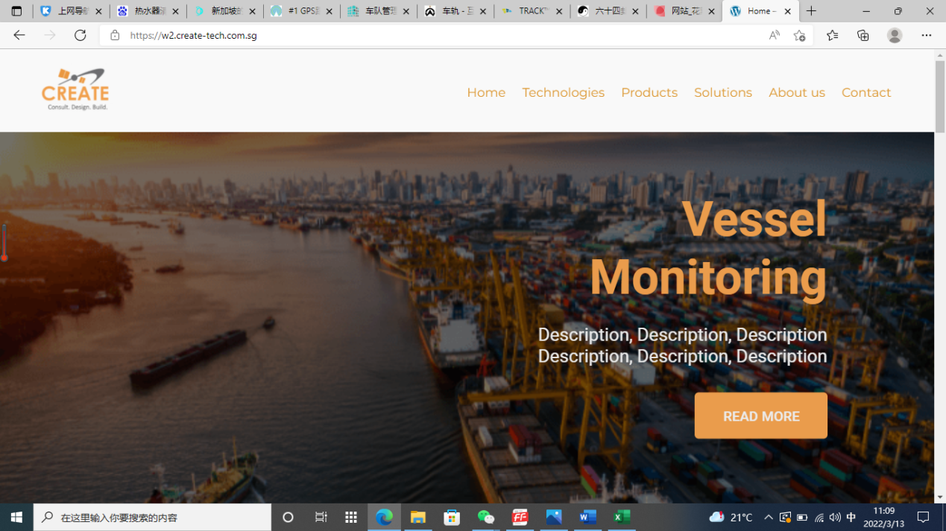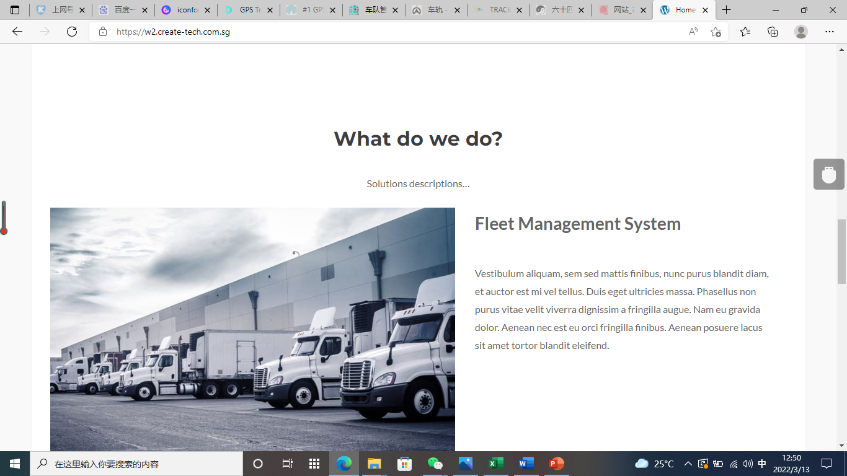 【文字】Create 致力于成为高精度定位跟踪系统和建筑物变形监测系统的先驱者和技术领导者。搭建适应各种应用场景的高精度位置信息和服务平台，在我们自己的专有算法和产品的支持下，无论您在哪里，我们都提供基于GNSS、UWB或惯性导航技术的整体解决方案
Who Is Create
Create aims to be a pioneer and technology leader in high-precision positioning and tracking systems and building deformation monitoring systems. Building a platform for high-precision location information and services for a variety of application scenarios, with our own proprietary algorithms and products to provide a total solution based on GNSS, UWB or inertial navigation technology, no matter where you are.

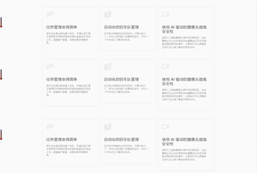
Solustions
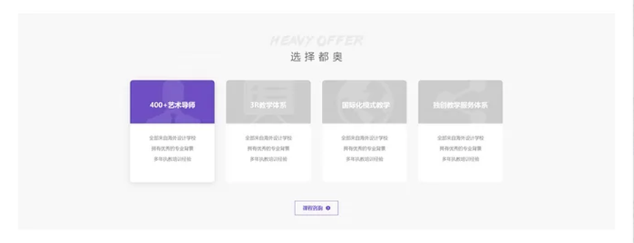
Why choose Create
【这里文字】
1. CREATE's products and solutions are targeted to solve customers' problems.
2. The TECHNICAL advantages of CREATE's products and solutions can solve the positioning and tracking problems in various complex environments.
3. CREATE's solutions can reduce safety risks, enhance efficiency and improve productivity.
4. The CREATE's solutions is conducive to widespread applications and cost effective.
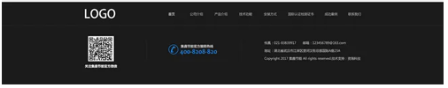

尾部信息
1. 下方也要有跟头部一样的菜单栏
2. 用小图标，电话，地址等
3. 放公司网址二维码（葛提供）
4. facebook 和 linke 颜色要协调
5. 底色不是黑，就是LOGO黄，或灰，不要现在的蓝

系统方案
典型的项目
- Fleet Management System车队管理系统
- Vessel Monotoring System船舶监控系统
变形检测
- Deformation Monotoring System变形监测系统
其他人员设备跟踪
- Construction Site Safety建筑工地安全
- Safety Supervision and Communication System for Large Groups朝圣者安全
- School Care学校护理
- Equipment Tracking设备跟踪
- Firefighter Tracking消防员追踪
- UWB Anti-Collision System防碰撞
- UWB Real-time Tracking System

